Experiment 2

Aim: To read an image using Python and apply Gaussian Blur to smooth and reduce noise in the image.

Algorithm
- Import the OpenCV library.
- Read the input image using cv2.imread().
- Apply Gaussian Blur using cv2.GaussianBlur().
- Display the original image.
- Display the blurred image.
- Wait for a key press.
- Close all windows.

Program
import cv2
img = cv2.imread("image.jpg")
blur = cv2.GaussianBlur(img, (5, 5), 0)
cv2.imshow("Original Image", img)
cv2.imshow("Gaussian Blur", blur)
cv2.waitKey(0)
cv2.destroyAllWindows()
Output
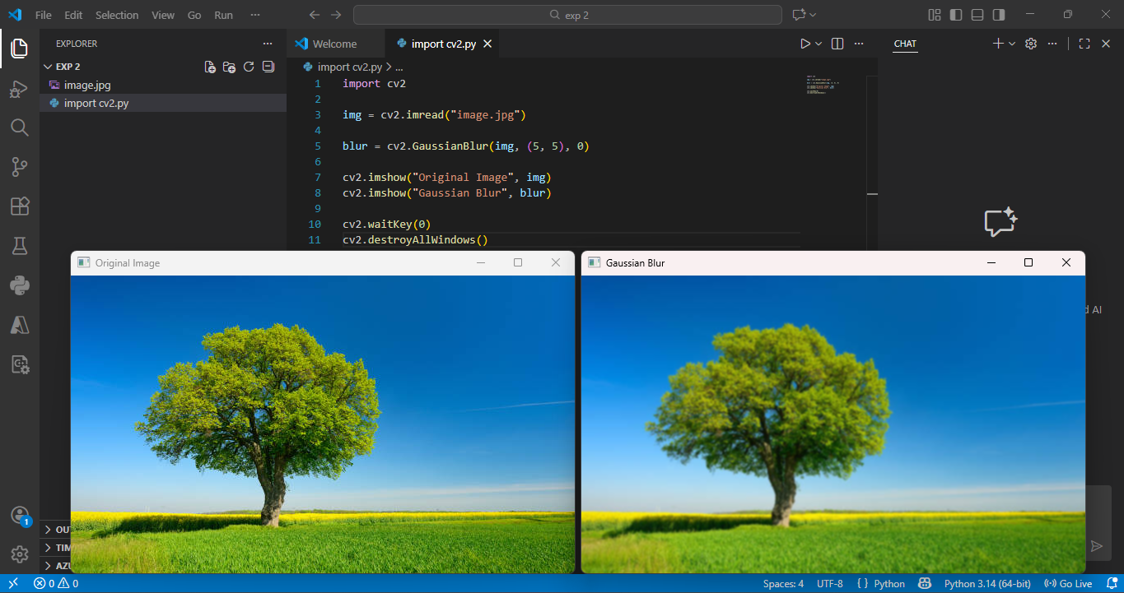

Result: The input image was successfully read and Gaussian Blur was applied using Python and OpenCV.

